**Principled Basics Documentation**

*Wireframe and Site Map:*

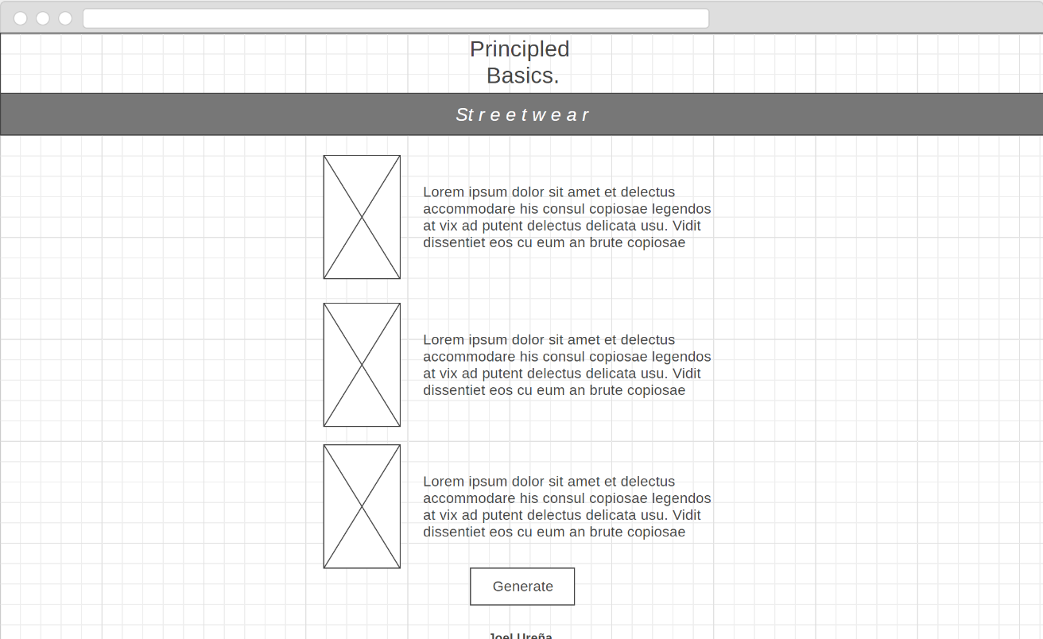

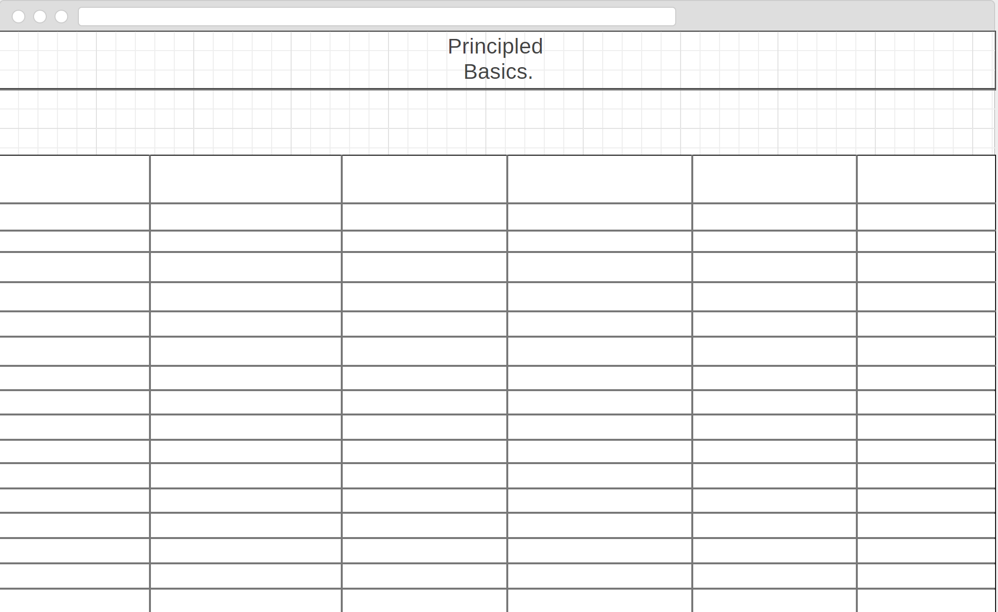

Old:

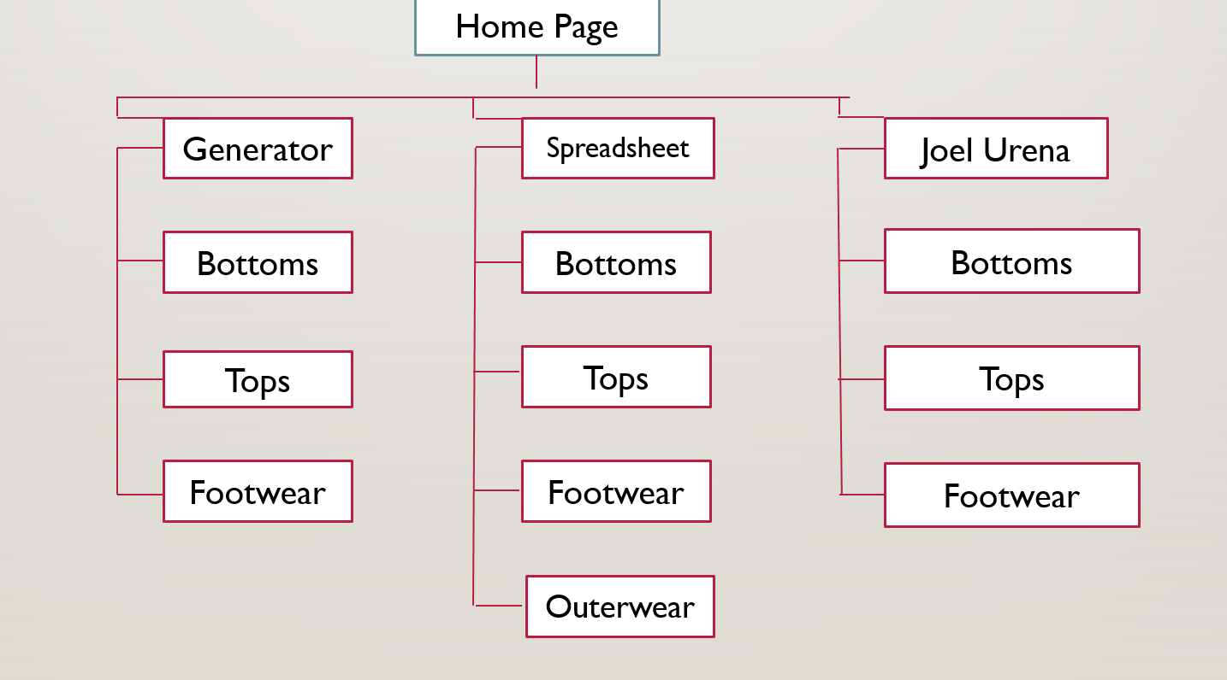

Current:

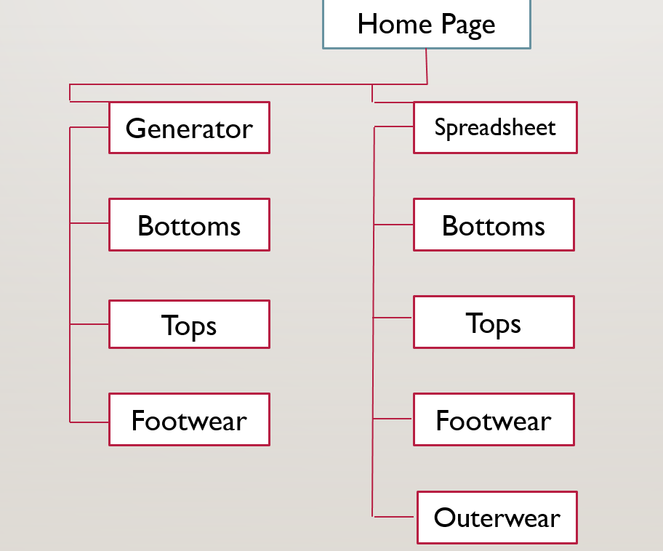

*Style Guide:*

Given that this project was a continuation of my midterm, my style guide was largely just me attempting to develop the very simplistic style that I had originally created. However, when it came it to the interactive spreadsheet, I figured that I should use color to illustrate the difference in budget and to give some sort of visual indication to stay away from the cheaper things; with that being said, I haven’t found a gradient that I’m happy with, so I conceded with the gradient of light red to white. I’m also very bothered by the border color of the spreadsheet, something that is due to the structuring of the bootstrap table class, but it was something I couldn’t change for some reason. On a brighter note, I am incredibly happy with how the tooltips turned out, the structure of them was something I thought I could do better than Logical Increments and I truly feel like I did.

*Things I Did and Didn’t Do:*

For the main thing I wanted to accomplish, the spreadsheet, I’m very happy with how it turned out as it’s allowed me to do everything I wanted to do, provide users with a list of budgeted bottoms, tops and footwear with links to everything and descriptions. I was lucky enough that the tooltip rendering could be treated the same as an HTML, however I couldn’t test this out with a screenreader. I only filled in one row with the tooltip as I haven’t made all the descriptions yet so it seemed a bit pointless to fill in the rest.

Regarding the generate page, I’m very happy with how it turned out visually, however I couldn’t get the JavaScript implementation to work with the images. I’ve also realized that the way I want it to be implemented properly requires more lists with descriptions, alt text for images and proper titles for the heading. I’ve also been thinking about placing the images in a flex box rather than using media items, as it would then properly scale next to the description, regardless of the size of the image.

Generally, I’m happy that the bulk of my website is done, especially the image collection and general file organization. However, before I officially roll this out and share this, I’d like to write proper descriptions for all the pieces and make it as accessible as possible.